**Bubble Sort**

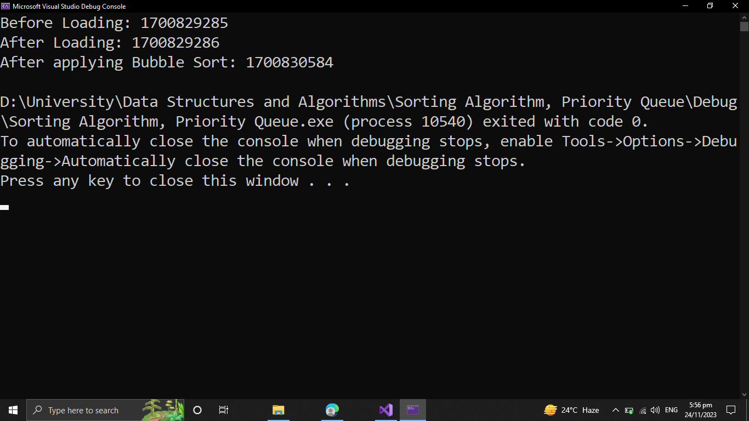

**Selection Sort**

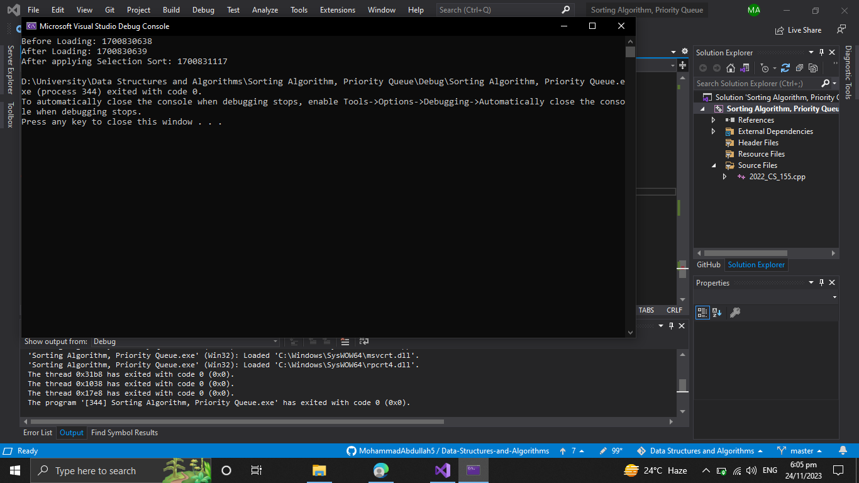

**Merge Sort**

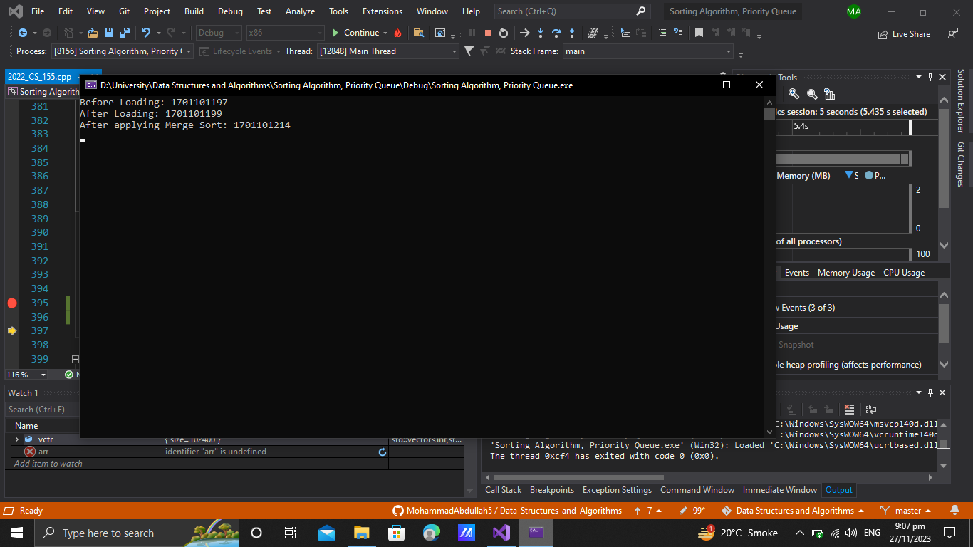

**Quick Sort**

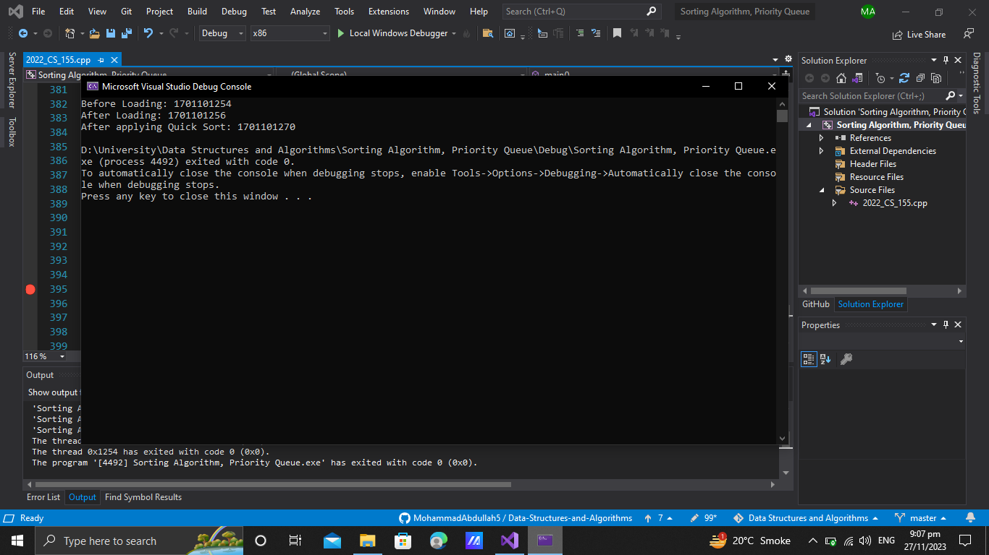

**Heap Sort**

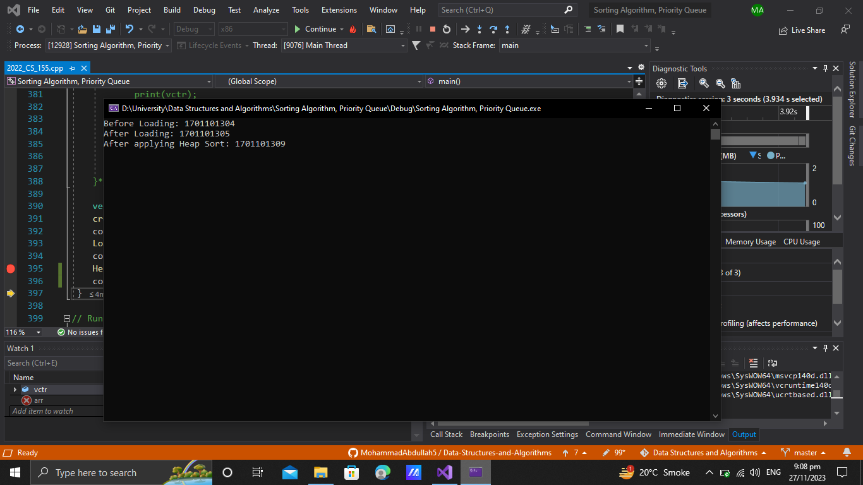

**Hashing 10 no**

**Insertion after every value**

**AVL Tree / Red black visualization**

**Binary Search Tree Logical Coding Problem**

**Time Complexity**

**5 number theoretical**